Exp 6

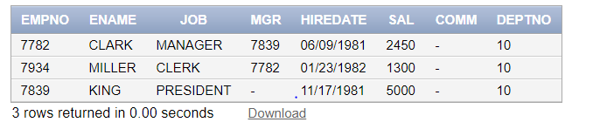select \* from emp where deptno in(select deptno from dept where loc = ‘NEW YORK’)

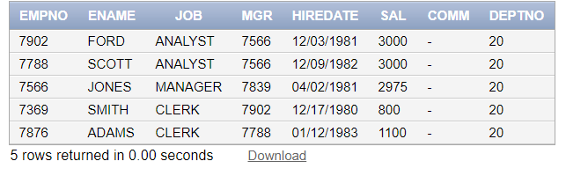

Select \* from emp where deptno in (select \* from dept where dname = ‘RESEARCH’)

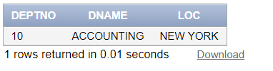

Select \* from dept where deptno in (select deptno from emp where sal >3000)

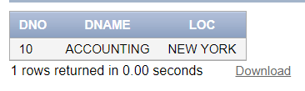

Insert into dept1(select \* from dept where deptno = 10)

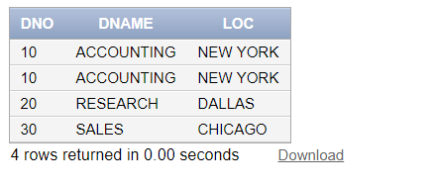

Insert into dept1 (select \* from dept where deptno in (select deptno from emp where sal>1000)

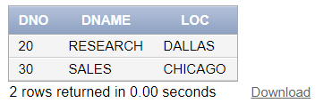

Delete from dept1 where dno in (select deptno from emp where job = ‘PRESIDENT’)

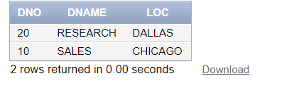

Update dept1 set dno = (select deptno from dept where loc = ‘NEW YORK’) where loc = ‘CHICAGO’

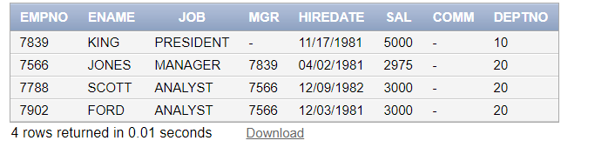

Select \* from emp where sal > (select (min(sal)+max(sal))/2 from emp)

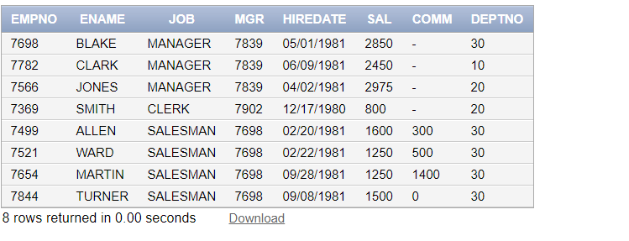

Select \* from emp where hiredate < (select hiredate from emp where ename = ‘KING’)

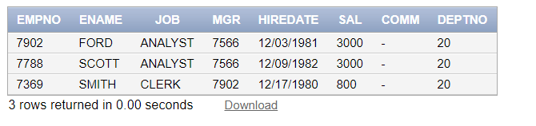

Select \* from emp where sal in(select sal from emp where ename =’FORD’ or ename = ‘SMITH’) order by sal desc

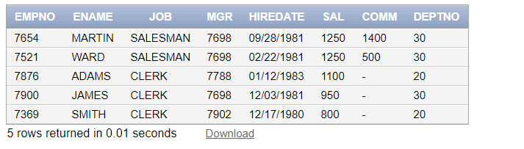

Select \* from emp where sal < all(select sal from emp where deptno =10)

Exp 7

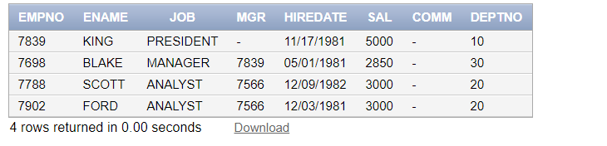

Selet \* from emp e1 where sal = (select max(sal) from emp e2 where e1.deptno = e2.deptno)

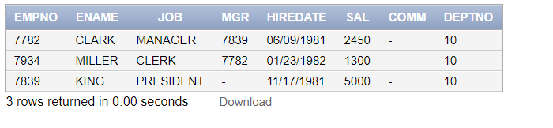

Select \* from emp e1 where e1.deptno in (select deptno from dept e2 where e2.loc = ‘NEW YORK’)

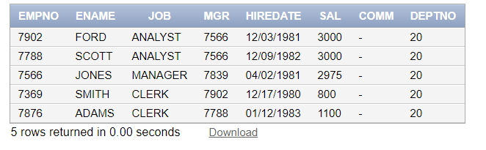

Select \* from emp e1 where e1.deptno in (select deptno from dept e2 where e2.dname = ‘RESEARCH’)

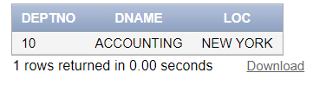

Select \* from dept d1 where d1.deptno in(select deptno from emp d2 where d2.sal >3000)

‘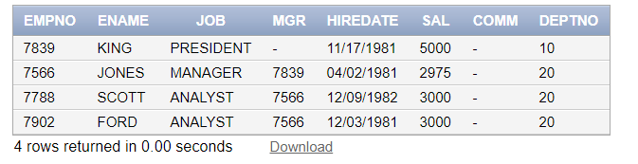select \* from emp e1 where e1.sal > (select (min(sal)+max(sal))/2 from emp)

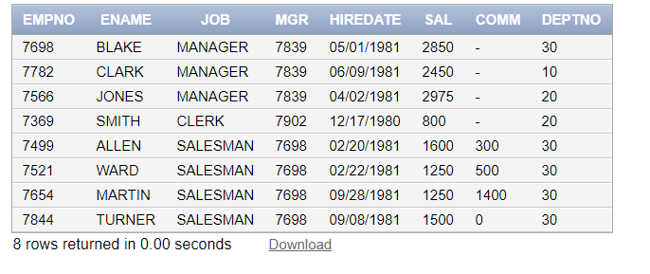

Select \* from emp e1 where e1.hiredate <(select hiredate from emp e2 where e2.ename= ‘KING’)

Exp 8

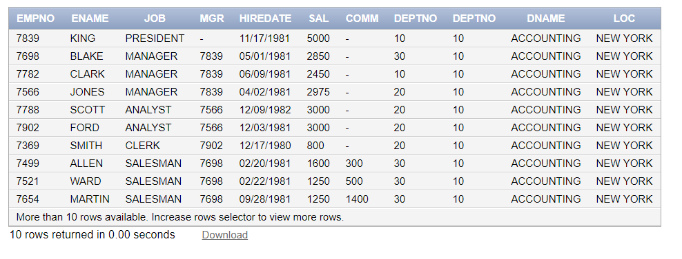

Select \* from emp cross join dept

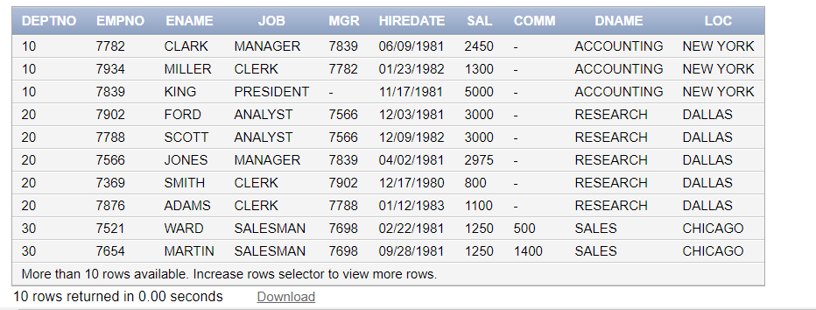

Select \* from emp natural join dept

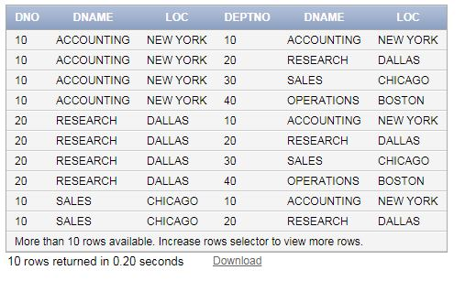

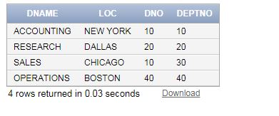

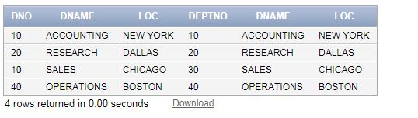

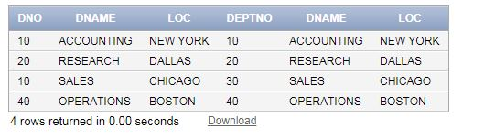

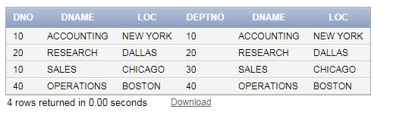

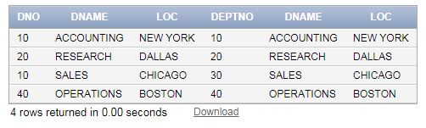

Queries

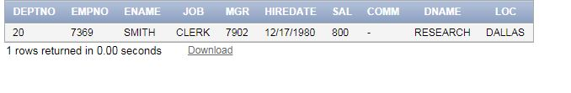

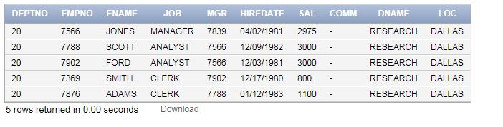

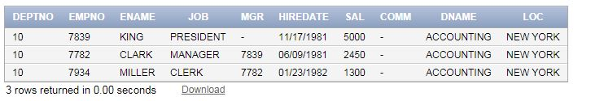

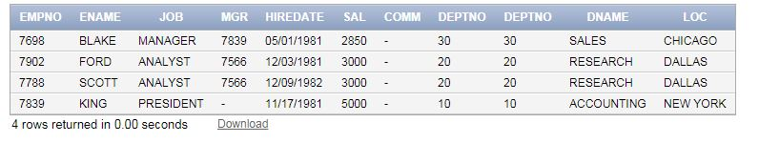

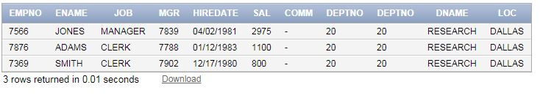

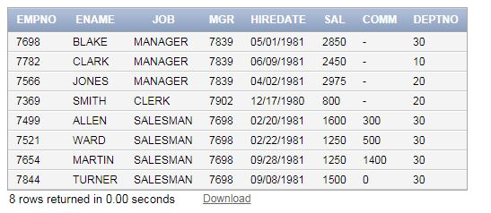

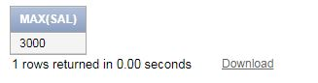

Extra

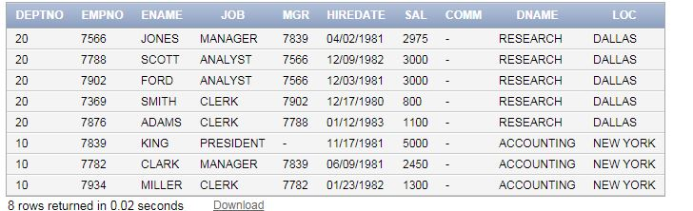

Exp 9

unique

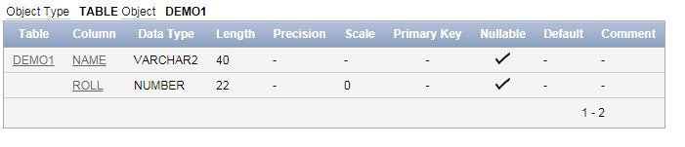

primary

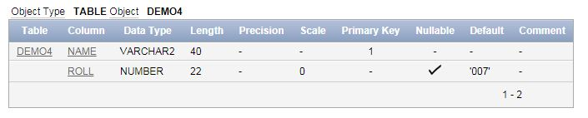

foriegn

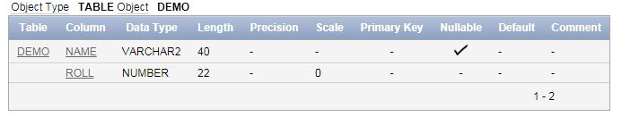

check

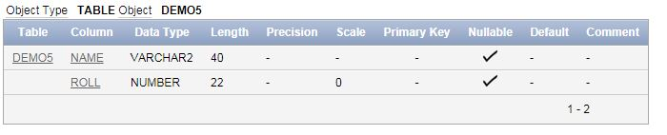

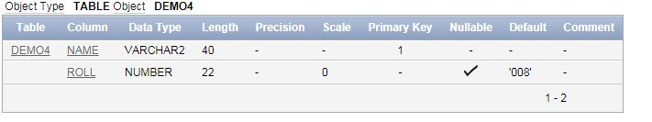

Create

Not null

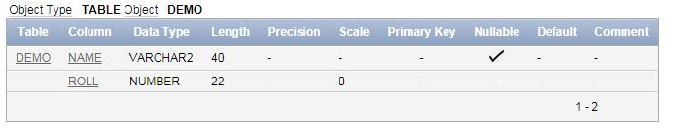

unique

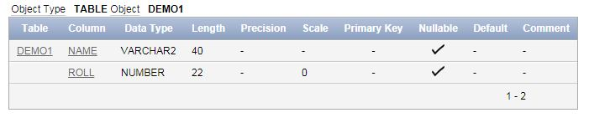

primary

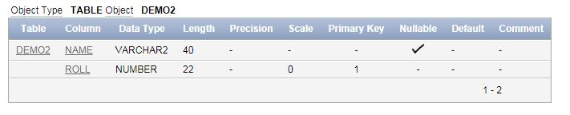

Foreign

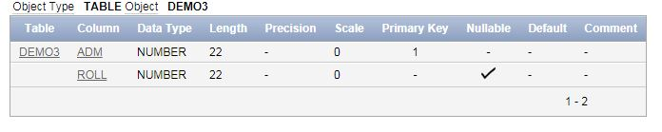

Default

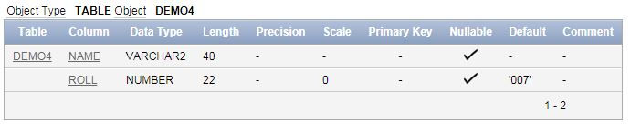

check

